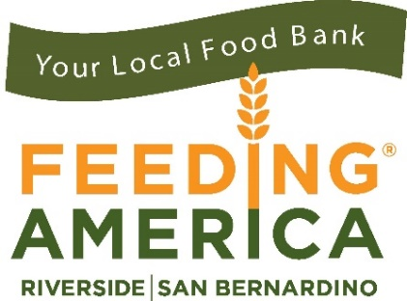
Contact:
Carolyn Solar: 951-359-4757 ext. 109. (office)
csolar@feedingamericaie.org (email)

FOR IMMEDIATE RELEASE

Feeding America Riverside | San Bernardino Receives $100,000 from S. Mark Taper Foundation to Aid Inland Empire Child Hunger Programs

(Riverside, CA – January 12, 2020) – The S. Mark Taper Foundation granted local food bank, Feeding America Riverside | San Bernardino (FARSB), with a substantial $100,000 grant to support hunger relief programs. This grant will support programs, such as those targeted to feed children in the Inland Empire, like FARSB’s Kids Markets and School Pantries.
In the Riverside and San Bernardino County region, over 800,000 people live below the poverty line and an astounding 445,000 residents struggle to put food on their tables. Hunger also impacts 1 in 5 children in this community.
“The S. Mark Taper Foundation, like FARSB, is passionate about enhancing the quality of people’s lives,” said FARSB CEO, Stephanie Otero. “We are eager to provide greater access to healthy, nutritious items and are able to do so through partnerships, like this one, with the S. Mark Taper Foundation,” said Otero.
“We value our partnership with FARSB and are proud to aid in their hunger relief efforts,” said Adrienne Wittenberg, Executive Director of the S. Mark Taper Foundation.
FARSB currently runs 5 kids markets, 5 college food programs, and 1 school pantry throughout the two service counties, which contributed to more than 18 million meals distributed through its programs in 2019.
To learn more about FARSB, visit www.FeedingIE.org.
About Feeding America Riverside | San Bernardino
Feeding America Riverside | San Bernardino (FARSB) is leading the fight against hunger in the Inland Empire by providing food access, emergency relief, education, and advocacy to families in Riverside and San Bernardino Counties. FARSB opened in 1980 as Survive Food Bank in response to the increasing concern about the dual problems of hunger and food waste in the Inland Empire. Today, FARSB is the primary source of food to over 200 local nonprofit organizations, distributing over two million pounds of food monthly to emergency food pantries, homeless shelters, soup kitchens, high-need elementary schools, halfway houses, senior centers, residential treatment centers, shelters for the abused, after school programs and group homes. With the help of these charity partners, they make up the largest hunger relief organization in the Inland Empire, making food security a reality for over 1.2 million people every year.
# # #

